# Sprint 3 Plan: SlugManager

Team: Asher Etherington, Kenneth Losier, Mia Santos, Nathan Le, Poppy Garner, Gino Zarich

Sprint Completion date: 5/20/24

Revision Number and Date:

## Goals: Implement task creation and marking them as completed. Add lots of styling throughout the website to make it look better.

## Task Listing:

User Story 3 (US.A):

As a project ‘administrator’, I want to be able to add tasks to a project so that I and any other team members can see the tasks displayed.

* Task 1

User Story 4 (US.B):

As a team member, I want to be able to see all tasks that are assigned to the project that I am a part of. I should also be able to mark tasks as completed.

* Task 2
* Task 3
* Task 4

Tasks:

* Task 1: Create a form in which administrators can create new tasks for a project. These new tasks should be added to the database (hours: 3)
  + Add description section for projects and tasks
* Task 2: Display tasks for the project page that was clicked on. Uncompleted tasks should be shown up top and completed tasks should be shown below. (hours: 2)
  + Tasks should be displayed as clickable buttons
* Task 3: The navbar should be different for if the user if they are project admin or not (2 hours)
  + If the user is admin then the navbar should show a button for adding tasks
  + If the user is admin there should be a form off to the left for adding users to the project
* Task 4: Keep track of tasks being clicked on and mark them as completed in the database (hours: 3)
* Task 5: Style all newly created .ejs files using css. Styling should follow the created figma outline. Clean up and re-style existing .ejs files as needed (backlog). (hours: 3)

Total for user story: 13 hours

## Team Roles:

Asher Etherington: Scrum Master

Kenny Losier: Developer

Mia Santos: Developer

Nathan Le: Developer

Poppy Garner: Developer

Gino Zarich: Project Owner

## Initial Task Assignment:

Gino Zarich: Task 1

Asher Etherington: Task 4

Kenny Losier: Task 2

Mia Santos: Task 5

Nathan Le: Task 3 + Task 5

Poppy Garner: Task 3 + Task 5

## Initial Burnup Chart:

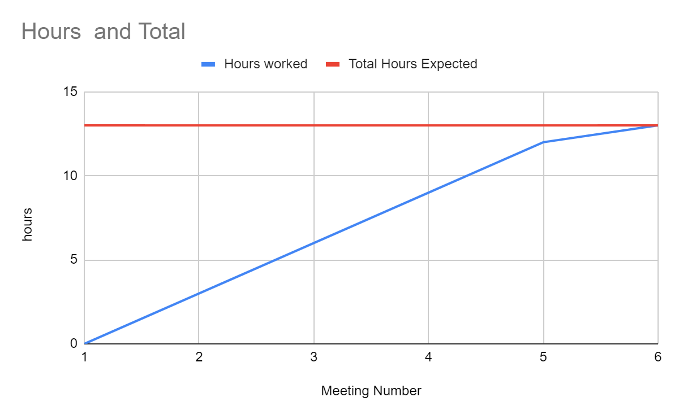

## Scrum Board:

| **User Story** | **To Do** | **In Progress** | **Done** |
| --- | --- | --- | --- |
| **US.A** |  |  | **Task 1** |
|  |  |  | **Task 2** |
|  |  | **Task 5 (half done)** |  |
| **US.B** |  |  | **Task 3** |
|  |  |  | **Task 4** |

## Definition of Done:

* Administrators should be able to create new tasks for projects
* All members of projects should be able to see all the tasks associated with that project
* All members of the project should be able to mark tasks as completed
* Non-administrator members should not be able to create new tasks
* All newly created web pages should be styled thoroughly

## Scrum Times:

Monday: Team Meeting 9:15-10:15 AM

Tuesday: Meeting with TA 2:15-3:15 PM

Wednesday: Team Meeting 9:15-10:15 AM

Friday: Team Meeting 9:15 - 10:15 AM